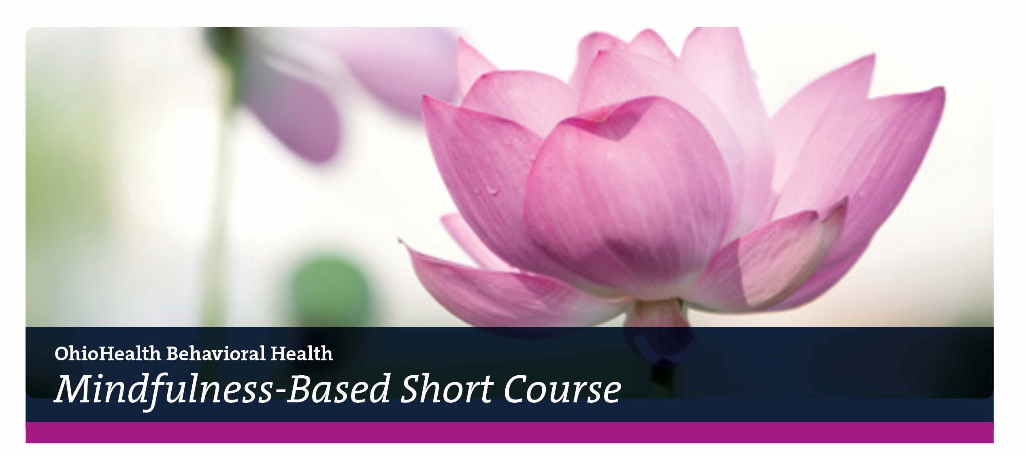



**A four-week abbreviated version of the evidence-based**

**Mindfulness-Based Stress Reduction Program**

**Due to concerns around COVID-19, the Mindfulness Program will not offer any in-person classes this quarter.**

***MBSC IS NOW AVAILABLE ONLINE LIVE!***

**These Mindfulness-Based Short Courses will be delivered live online via the Zoom video conferencing platform. All sessions, including the Introductory Program Overview, will be facilitated via Zoom. Participants will** **engage with the facilitator and one another through their computer with high-speed internet connection during class time and for home assignments and practice. Smart devices, such as phones and tablets, are not recommended. Please ensure your computer meets minimum requirements for participation--speakers, microphone and video capabilities. Sessions will not be recorded.**

**Registration is on a first-come, first-served basis. Registration closes 2 business days prior to the first session.**

**For additional information and to register, contact:**

OhioHealth’s Mindfulness Program at 614-788-4725 or email at [mindfulness@ohiohealth.com](mailto:mindfulness@ohiohealth.com)

**Winter Quarter 2021 MBSC Schedule**

***Two options available: morning and evening!***

**Please plan to attend a *Free* Introductory Program Overview Session, as attendance is required before signing up.**

**Registration is required for the Free Introductory Program Overview to receive link via email.**

***4-Week Mindfulness-Based Short Courses***

***Free***Introductory Program Overview Session: Thursday, January 21, 3:30 – 5:00 pm

**Evening Course: Thursdays, January 28 – February 18, 3:30 – 5:00 pm**

Facilitators: Kevin Kraska, MSW, LISW-S and Linnea Clouse, LPCC, LICDC

***Free***Introductory Program Overview Session: Tuesday, February 16, 8:30 – 10:00 am

**Morning Course: Tuesdays, February 23 – March 16, 8:30 am – 10:00 am**

Facilitators: Jessica Englehart, LPCC-S, ATR, RYT and Linnea Clouse, LPCC, LICDC

**Fee** for the 4-Week Program: $95 (includes 6 hours class time, modest workbook, practice recordings).

OhioHealth Associates receive a 50% discount on registration fee ($47.50).

OhioHealth Fitness Center members receive a 10% discount on registration fee ($85.50).

OhioHealth is accredited by the Ohio State Medical Association to provide continuing medical education (CME) for physicians.

OhioHealth designates this series of live activities for a maximum of 6.0 *AMA PRA Category 1 credit(s).* Physicians should only claim credit commensurate with the extent of their participation in activity.

Nursing: The Ohio Board of Nursing recognizes events approved by a nationally recognized accreditation system of continuing education approval.

***Objectives:***

1. Identify stress as it arises and intervene/manage it.
2. Develop the capacity for “presence” using empathetic/compassionate listening skills.
3. Demonstrate thoughtful and responsive behaviors when communicating with others.